**Assignment 8.1**

1. Use the package RcmdrPlugin.IPSUR.

data(RcmdrTestDrive)

and perform the below operations:

1. Calculate the average salary by gender and smoking status.

**Answer:**

data1<-RcmdrPlugin.IPSUR::RcmdrTestDrive

# To find the average salary by gender

With(data1, by(salary, gender, mean))

# to find the smoking status by gender

table(data1$gender, data1$smoking)



OR

With(data1, table(smoking, gender)) or with(data1, table(gender,smoking))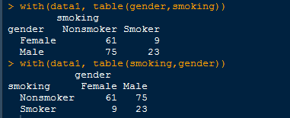

b. Which gender has the highest mean salary?

**Answer:**

Male gender has highest mean salary.

c. Report the highest mean salary.

**Answer:**

Mean(data1$salary)



d. Compare the spreads for the genders by calculating the standard deviation of salary by gender.

**Answer:**

With(data1, by(salary, gender, sd)

